“Emergency management and successful disaster response is a team effort. It starts with neighbors helping neighbors and goes all the way up to the federal government being able to coordinate resources down to the state and local officials.”– FEMA Administrator Brock Long
 | SAFETY AND SECURITY
 | Mandatory evacuations in place throughout the Carolinas and Virginia. National Guardsmen are assisting with traffic control points and lane reversals for evacuation routes. FEMA Urban Search & Rescue Teams and U.S. Coast Guard are pre-positioned to assist with necessary rescues. Department of Defense is coordinating rotary wing aircrafts, swift water rescue boats, geospatial specialists, trained rescue personnel, and additional ground transportation with high water capability for cargo and/or people movement. An Incident Management Team is mobilizing to Raleigh for quick deployment to areas needing emergency road clearing and debris removal.
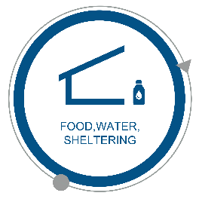 | FOOD, WATER, SHELTERING
 | FEMA and voluntary agencies are positioning resources in the Carolinas, Virginia and West Virginia to assist with sheltering needs. Commodities include blankets, cots, medical supplies and equipment, and infant toddler kits. Shelters are open in the Carolinas and Virginia. EPA and American Water Works Association are hosting a Water/Wastewater Agency Response Network (WARN) call to help identify any anticipated water system needs.
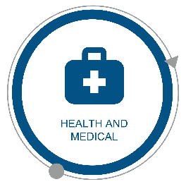 | HEALTH AND MEDICAL
 | Federal health officials and HHS Incident Management Teams are engaged with state and local governments to monitor developments, and forecast future needs. Disaster Medical Assistance Teams are staged in North Carolina, and are available for missions in South Carolina. FEMA ambulance contracts are staged for North Carolina, South Carolina and Virginia patient movement. HHS assets and ambulances are staged to support impacted areas. Two federal medical stations are staged in Atlanta.
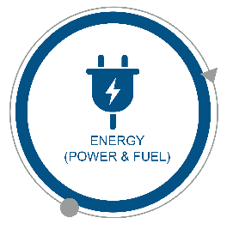 | ENERGY (POWER & FUEL)
 | Electric companies from neighboring states are sending crews and resources to help energy companies in anticipation of the impacts of Hurricane Florence. Defense Logistics Agency (DLA) national fuel contract is activated, and the U.S. Army Corps of Engineers is assisting fuel transport to the Carolinas and Virginia. DLA is sent generators to North Carolina, South Carolin and Virginia ahead of the storm.
 | COMMUNICATIONS
 | FEMA Disaster Emergency Communications capabilities supporting command and control communications for IMATs, US&R teams, NDMS teams, and Incident Support Bases. American Radio Relay League is shipping seven Ham Aid kits to assist with emergency communication needs.
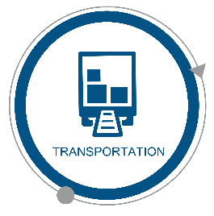 | TRANSPORTATION
 | Ports are open with restrictions in Hampton Roads, Newport News, Norfolk and Richmond, Va. Wilmington and Morehead City, N.C. ports are closed. Beaufort and Charleston, S.C. ports are open with restrictions, and the Georgetown, S.C. port is closed. Amtrak is operating on a modified schedule; no operations south of Richmond, Va. Freight trains are staging and securing loaded coal trains in Newport News. Wilmington International, Rocky Mount-Wilson Regional, New Bern Coastal Carolina, Charleston AFB/International and Florence Regional Airports are closed.
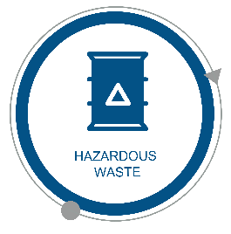 | HAZARDOUS WASTE
 | The Pipeline and Hazardous Materials Safety Administration issued a 30-day waiver of the Hazardous Materials Regulations for North Carolina, South Carolina and Virginia. Oil and Natural Gas Sector Coordinating Council is working with DOE and ESF-1 to address fleet movement issues, including fuel availability, transportation waivers and other logistics challenges.

